CONCEPTUAL PROJECT 1
FRAMEFLOW
AI/ML Optical-Flow Based Temporal Interpolation
of Geostationary Satellite Imagery
Problem Statement 12 - "Fill in the Frames Seamlessly"
Detailed Project Report
University | Woxsen University
Programme | B.Tech CSE - Artificial Intelligence and Machine Learning
Batch | 2025 - 2029
Project Domain | Machine Learning / Computer Vision / Remote Sensing
Prepared by | Project Team - Atharva Kanojia and team

Academic Year 2026
Mentor: ______________________________

Executive Summary
FrameFlow is a machine-learning based research prototype for filling temporal gaps in geostationary satellite imagery. The project starts from a practical limitation: satellite observations are separated in time, while important weather structures can change substantially between two observations. The proposed system treats the missing observation as an intermediate frame and estimates it from the surrounding frames using RIFE HDv3, an optical-flow based video frame interpolation model. The work was developed against ISRO Bharatiya Antariksh Hackathon 2026 Problem Statement 12, which asks for AI/ML based interpolation, validation against denser satellite observations, and a visual dashboard [1].
The implementation combines image preprocessing, RIFE inference, a confidence proxy based on forward/backward warping consistency, quantitative evaluation, a FastAPI service, and a React/Vite dashboard. The project documentation also defines a broader architecture for training on high-cadence feeds such as GOES-19 and Himawari and applying a domain-adapted model to INSAT-3DS/3DR TIR1. The currently documented experimental results, however, are based mainly on GOES-16 Hurricane Ian data, including a ten-sequence RGB validation and a dedicated ABI Band 13 thermal experiment [2][5][6][7].
The results are encouraging at the prototype level. Across ten non-overlapping GOES-16 RGB temporal samples, RIFE obtained a mean MAE of 8.598 compared with 17.747 for linear interpolation, a mean PSNR of 24.839 dB versus 19.533 dB, and a mean SSIM of 0.8109 versus 0.6809. In the Band 13 experiment, the reconstructed brightness-temperature frame achieved 0.358 K MAE, 0.766 K RMSE, 45.836 dB PSNR, and 0.9925 SSIM, all better than the linear baseline in that evaluated crop [6][7]. These values should be read as evidence of feasibility, not as proof of operational meteorological accuracy.
Scope note FrameFlow is a research prototype. It is intended to demonstrate temporal interpolation, evaluation, and visualization; it is not presented as an operational forecasting or disaster-warning system.

Abstract
Temporal resolution is a recurring limitation in satellite-based weather monitoring. When a geostationary platform produces an image every fixed interval, fast cloud and storm evolution can occur between observations. FrameFlow studies whether a learned frame interpolation model can reconstruct useful intermediate satellite imagery without requiring another satellite observation. The project uses RIFE HDv3 as the primary interpolation engine, adapts the input path for satellite imagery, and evaluates the generated frame against a withheld ground-truth frame using MAE, RMSE, PSNR, and SSIM. A confidence proxy based on forward/backward warping residuals is provided alongside the generated image so that visually difficult regions can be inspected instead of treating every pixel as equally reliable. The system is exposed through a FastAPI backend and a React/Vite dashboard, with browser-level end-to-end verification included in the implementation. The work demonstrates a complete research workflow from frame input to interpolation, quality measurement, and visual inspection, while identifying the next steps required for real INSAT deployment, broader cross-event validation, and satellite-specific fine-tuning [2][4][8][9].

Contents
1. Introduction and Background
2. Problem Definition and Objectives
3. Background Study and Related Work
4. System Requirements and Design Goals
5. Proposed System Architecture
6. Data Sources and Preprocessing
7. RIFE Model and Interpolation Method
8. Confidence Estimation and Error Visualization
9. Software Implementation
10. Evaluation Methodology
11. Experimental Results
12. Discussion
13. Limitations and Risk Areas
14. Future Work
15. Conclusion
References
Appendix A - API Summary
Appendix B - Documentation Status Note

Abbreviations and Key Terms
Term | Meaning
ABI | Advanced Baseline Imager
BT | Brightness Temperature
CUDA | Compute Unified Device Architecture
E2E | End-to-End
FSIM | Feature Similarity Index
GIF | Graphics Interchange Format
IFNet | Intermediate Flow Network
INSAT | Indian National Satellite System
MAE | Mean Absolute Error
MOSDAC | Meteorological and Oceanographic Satellite Data Archival Centre
PSNR | Peak Signal-to-Noise Ratio
RMSE | Root Mean Squared Error
RIFE | Real-Time Intermediate Flow Estimation
SSIM | Structural Similarity Index
TIR | Thermal Infrared
VFI | Video Frame Interpolation

1. Introduction and Background

1.1 Context
Satellite images are often used as a time series rather than as isolated pictures. The value of the sequence comes from observing how clouds, storm systems, and other surface or atmospheric structures change. The project problem statement highlights a simple difficulty: if a geostationary satellite observes an area every 30 minutes, any change that occurs inside the interval is not directly observed [1].
The problem becomes important during rapidly changing events. A storm cell can intensify, shear, expand, or lose structure between two observations. A fixed observation cadence therefore creates a temporal gap in the very period where the scene may be changing most quickly. FrameFlow asks whether that gap can be reduced computationally by estimating an intermediate frame from the two surrounding observations.
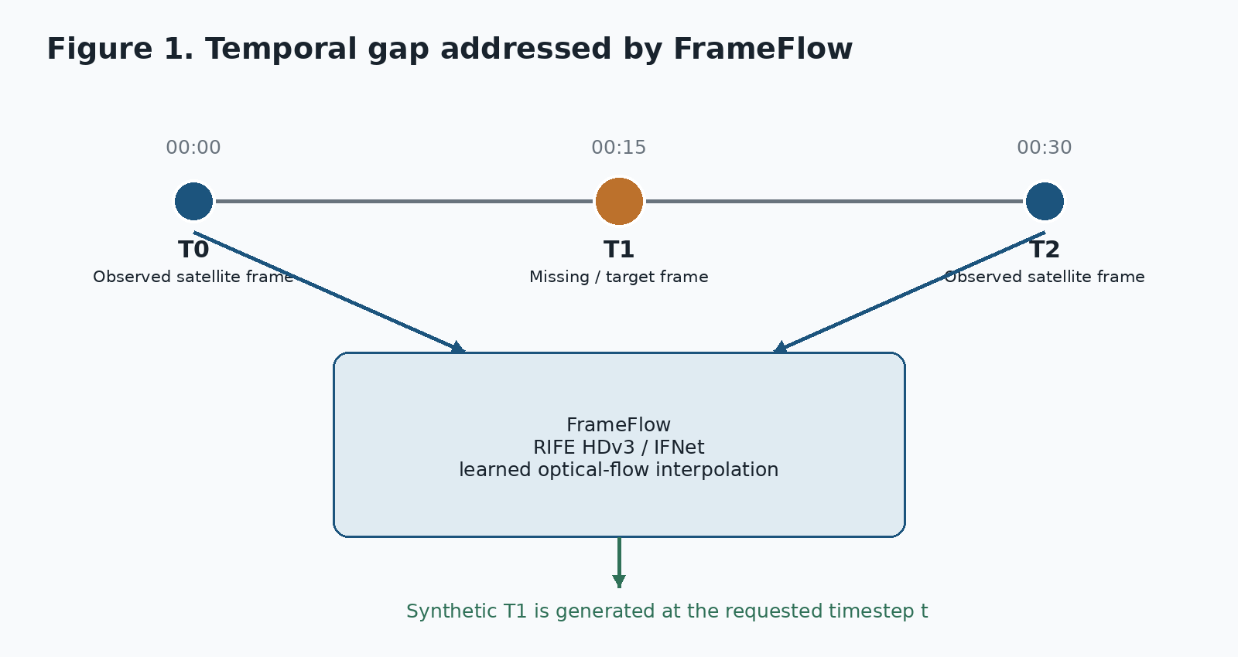
Figure 1. The basic temporal interpolation problem addressed by FrameFlow.

1.2 Why Frame Interpolation Is a Reasonable Approach
The central assumption is not that the missing image contains completely new information. Instead, the two surrounding images contain evidence about how visible structures are moving or changing. Optical flow provides a way to represent that change as a field of motion vectors, and a learned interpolation network can use the estimated motion to produce an intermediate image. This is similar in spirit to video frame interpolation, but the satellite setting introduces different data characteristics: the input may be a single thermal band, image values have physical meaning, and weather structures do not always behave like rigid objects [2][4].

1.3 Project Motivation
- Improve the temporal continuity of geostationary satellite imagery without additional satellite hardware.
- Explore whether a pretrained flow-based interpolation model can be useful on satellite data before investing in a satellite-specific training pipeline.
- Provide a visual way to inspect both the generated frame and the regions where the interpolation is less consistent.
- Build a measurable evaluation workflow instead of relying only on visual judgment.
- Create a working software pipeline that can later be connected to high-cadence GOES/Himawari training data and the INSAT target workflow described in the architecture.

2. Problem Definition and Objectives

2.1 Problem Statement
The official problem statement asks for an AI/ML optical-flow based technique that takes two consecutive satellite images and generates intermediate frames. It specifically calls for improved temporal resolution, validation against higher-frequency datasets such as Himawari or GOES-19, metrics such as SSIM, MSE and PSNR, and a web dashboard showing observed and interpolated animations [1].

2.2 Working Problem Formulation
Let T0 and T2 denote two observed satellite frames and let T1 denote the real intermediate frame that is withheld during evaluation. The model receives T0, T2 and an interpolation fraction t, where t=0.5 corresponds to the midpoint. It produces a prediction T_hat1. The evaluation then compares T_hat1 directly with T1. During actual use, T1 is unknown and the generated frame is treated as an interpolated estimate rather than a measured observation [3][4].

2.3 Objectives
- Implement optical-flow based temporal interpolation using a pretrained RIFE/IFNet model.
- Build the preprocessing path needed for satellite imagery, including input formatting and normalization.
- Provide quantitative comparison against a simple linear interpolation baseline.
- Experiment with GOES-16 RGB and ABI Band 13 thermal imagery.
- Add a confidence proxy based on forward/backward warping consistency.
- Expose inference through an API and make the workflow usable from a browser-based dashboard.
- Keep the implementation reproducible and document the limitations that remain before operational deployment.

2.4 Scope
The scope of the current project is interpolation between known bracketing frames. It does not attempt to forecast beyond the last observed frame, infer unseen convective events that occur entirely between observations, or turn the interpolated pixels into an independent quantitative weather retrieval. The model card explicitly places these uses outside the intended scope [4].

3. Background Study and Related Work

3.1 Optical Flow and Frame Interpolation
Traditional frame interpolation methods estimate motion between consecutive frames and then warp image content to the desired time. The problem statement notes that classical approaches often produce blur and artifacts in fast or non-linear cloud motion [1]. Learned VFI methods try to estimate a more useful intermediate representation from examples rather than applying a purely mechanical blend.

3.2 RIFE / IFNet
FrameFlow uses the RIFE family as its primary interpolation engine. The project model card identifies an IFNet-based RIFE backbone with coarse-to-fine intermediate-flow estimation, residual refinement, and support for arbitrary interpolation time t in the open interval (0,1) [4]. The integration keeps the upstream network architecture intact and wraps the required inference path locally [8].

3.3 Why RIFE Was Selected
The architecture document gives three practical reasons for choosing RIFE: it is flow-based, it supports arbitrary-time interpolation, and it is relatively small compared with many other video interpolation networks. The project repository also contains comparator paths for EMA-VFI, IFRNet, Super-SloMo, FILM, classical flow baselines, and persistence-style baselines as part of the wider evaluation plan [2].

3.4 Prior Satellite-Specific Work
The project architecture identifies the work by Vandal and Nemani on temporal interpolation of geostationary satellite imagery as a particularly relevant reference. Their reported Band 13 results are used in the project documentation as a quality bar for the production training phase [2]. This is useful because it keeps the target grounded in a satellite-specific result rather than comparing only against generic video benchmarks.

4. System Requirements and Design Goals

4.1 Functional Requirements
ID | Requirement
FR-01 | Accept two input frames and a requested timestep.
FR-02 | Preprocess satellite or image inputs into the tensor shape expected by RIFE.
FR-03 | Generate an intermediate frame using RIFE HDv3.
FR-04 | Return the generated image and a confidence map.
FR-05 | Compute evaluation metrics when a ground-truth middle frame is available.
FR-06 | Provide model/device health information through the API.
FR-07 | Display inputs, outputs, confidence and metrics in a web interface.
FR-08 | Handle invalid input files without crashing the browser workflow.

4.2 Non-Functional Requirements
- Reproducibility: documented environment, fixed data conventions and explicit contracts.
- Compatibility: CPU fallback for testing and CUDA acceleration when available.
- Measurability: every evaluation should expose numerical metrics rather than relying only on screenshots.
- Maintainability: isolate the RIFE implementation behind a wrapper instead of distributing upstream model details across the project.
- Clarity: keep observed frames, generated frames and quality indicators visually distinguishable in the dashboard.

5. Proposed System Architecture
The implementation is organized as a pipeline rather than as a single script. At a high level, the system moves through input handling, preprocessing, model inference, confidence estimation, evaluation and visualization. The broader architecture separates the expensive offline path from the web delivery path, with the model output converted into web-ready artifacts for larger deployments [2].
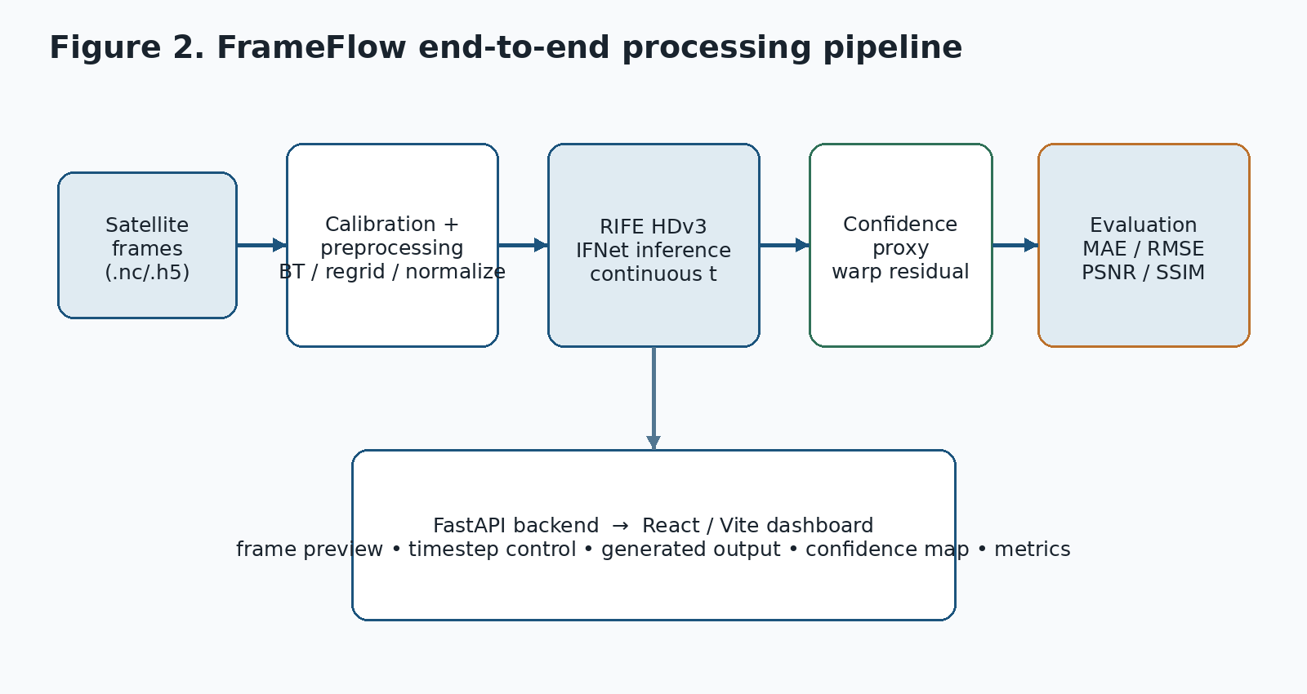
Figure 2. High-level processing path implemented by FrameFlow.

5.1 Data Layer
The architecture defines a common analysis grid and a canonical three-dimensional cube layout with dimensions time, y and x. The data contract stores brightness temperature as float32 Kelvin and keeps timestamps and geographic coordinates alongside the data [3]. This design is intended to prevent each module from inventing its own assumptions about shape, units, or coordinate order.

5.2 Preprocessing Layer
Satellite inputs pass through calibration, normalization, spatial alignment and masking steps before inference. The long-term architecture proposes reading common satellite file types such as NetCDF and HDF5, converting values to brightness temperature, regridding to a shared geographic grid, and normalizing the thermal field [2][4].

5.3 Model Layer
The model layer contains the RIFE integration. The local wrapper handles image conversion and post-processing, while the upstream RIFE network remains isolated inside the project [8]. The implementation supports both CPU and GPU inference, and the environment documentation verifies CUDA on an NVIDIA GeForce RTX 4070 Laptop GPU [4][5].

5.4 Service Layer
A FastAPI backend provides the application boundary. The current API exposes health information, model information, interpolation and evaluation endpoints. This keeps the browser independent from the Python model internals and also makes inference easy to test separately from the UI [9].

5.5 Presentation Layer
The frontend is built using React and Vite. Users select two frames, choose a timestep, trigger interpolation, and inspect the returned image, confidence map and runtime information. The dashboard is deliberately focused on the scientific task rather than on generic application features [10].

6. Data Sources and Preprocessing

6.1 Intended Data Strategy
The architecture proposes a train-on-dense, deploy-on-sparse workflow. GOES-19 ABI and Himawari-9 AHI provide approximately 10-minute observations and therefore offer natural ground truth for a hold-out-the-middle training or evaluation design. INSAT-3DS/3DR TIR1 is the intended operational target because its approximately 30-minute cadence leaves larger gaps to fill [2][4].
Current experimental status The implemented validation artifacts available in the project repository are primarily based on GOES-16 Hurricane Ian data. The broader GOES-19/Himawari-to-INSAT workflow is the project architecture and roadmap, not a claim that the present prototype has already completed full INSAT operational validation.

6.2 GOES-16 RGB Validation Dataset
The documented RGB experiment uses GOES-East / GOES-16 data associated with Hurricane Ian on 27 September 2022. Ten non-overlapping temporal triplets were selected so that each prediction could be checked against a distinct withheld middle frame. The dataset record describes the data as a public-domain GOES-16 GEOCOLOR sequence extracted from a historical weather animation, with the frames converted into arrays for RIFE processing [6][11].

6.3 ABI Band 13 Thermal Dataset
The Band 13 experiment uses GOES-16 ABI Level-2 CMIP data from the same Hurricane Ian period. Band 13 is a 10.3 micrometer clean infrared channel expressed as brightness temperature in Kelvin. A 512 x 512 crop was used for the reported test, and the experiment follows a strict T0 / ground-truth T1 / T2 temporal triplet [7].
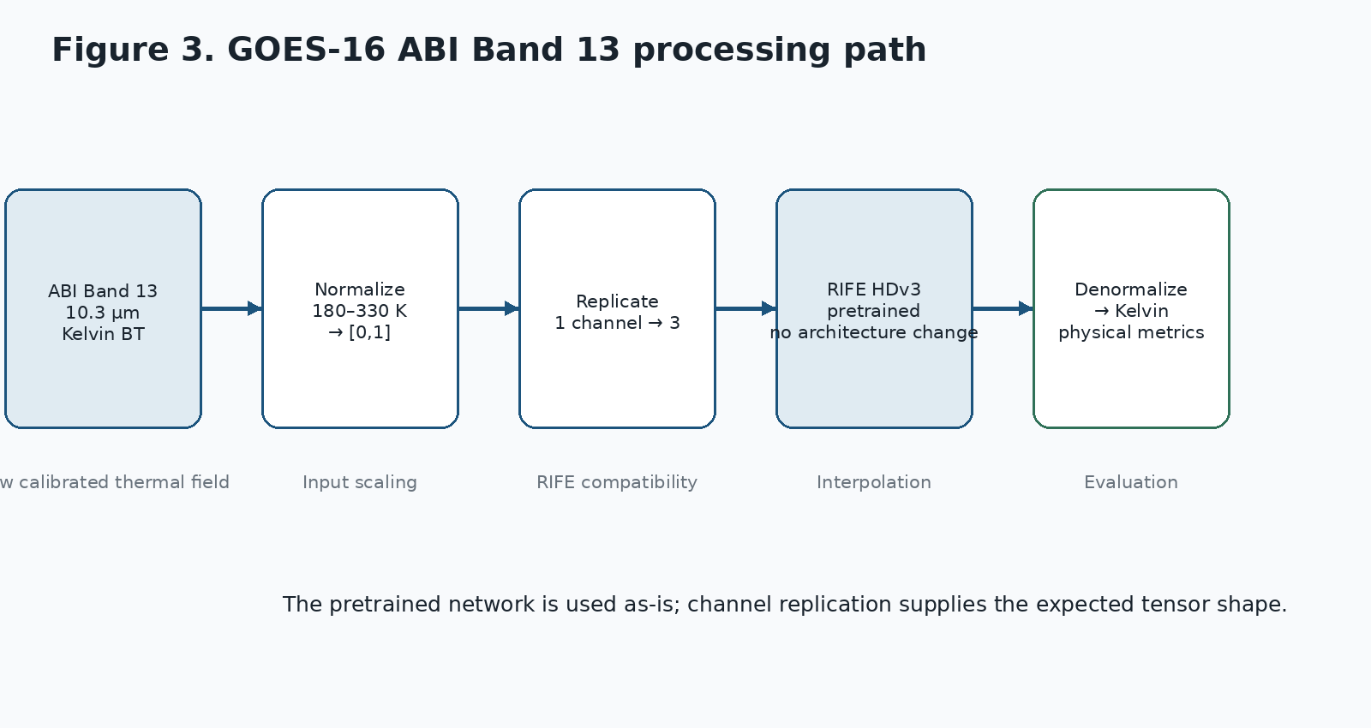
Figure 3. Thermal Band 13 processing path used in the prototype experiment.

6.4 Normalization and Physical Units
For the Band 13 model input, the prototype normalizes values spanning 180 K to 330 K into the [0,1] range. Because RIFE is a pretrained RGB video model, the single thermal channel is replicated to three channels before inference and one output channel is converted back to the physical domain [7][12]. This is a compatibility step; it does not add information or modify the RIFE network.
The project contracts separately define a fixed physical metric range of 180 K to 320 K, equivalent to a 140 K evaluation span, for full-reference metrics. This distinction is intentional: the normalization range is an input scaling convention, while the metric range is a comparison convention used to keep results comparable across frames and methods [3].

6.5 Registration and Masking
The project documentation treats spatial alignment as a prerequisite rather than as something to be repaired after interpolation. In the broader architecture, regridding uses a cached KD-tree so that the spatial mapping can be reused instead of rebuilt for every frame [2]. In the Band 13 experiment, invalid or off-disk values are masked before evaluation so that space-view pixels do not distort the reported thermodynamic error [7].

7. RIFE Model and Interpolation Method

7.1 RIFE HDv3 / IFNet
RIFE is the core inference model in the prototype. The model card describes the production configuration as an approximately 9.8 million parameter IFNet-based system that estimates intermediate motion and refines the generated image. Its ability to accept arbitrary t is important because the same network can be used for midpoint interpolation and, by recursion, for finer temporal densification [4].

7.2 Inputs and Outputs
Element | Role
Observed frame T0 | Earlier bracketing frame
Observed frame T2 | Later bracketing frame
t | Interpolation fraction, normally 0.5 for midpoint evaluation
Predicted T1 | Generated intermediate frame
Confidence map | Per-pixel consistency estimate
Metrics | When ground truth exists: MAE, RMSE, PSNR, SSIM and related values

7.3 Linear Baseline
A simple linear average is used as the primary baseline: T_hat1 = (T0 + T2) / 2. It is intentionally basic. A baseline of this kind answers a useful question: is the learned model doing more than averaging the two observed images? The evaluation documents show that RIFE consistently improves over this baseline on the reported RGB and Band 13 experiments [5][6][7].

7.4 Why the RIFE Architecture Was Not Modified
The prototype keeps the RIFE network unchanged and adapts the input representation around it. This decision reduces implementation risk and makes the experiment easier to interpret: any improvement can be attributed to using the pretrained interpolation model rather than to a newly designed satellite-specific network. The integration layer is responsible for shaping inputs and restoring outputs [8].

8. Confidence Estimation and Error Visualization

8.1 Motivation
A generated frame should not be presented as equally reliable everywhere. Regions with newly exposed structure, large displacement, or inconsistent flow can be harder to reconstruct. FrameFlow therefore adds a confidence proxy that uses the model's own dense optical flow instead of assigning a generic score to the whole image [8].

8.2 Computation
- RIFE estimates the bidirectional flow fields from the two input frames toward the requested time.
- The first and second input frames are warped toward the target time.
- The two warped estimates are compared pixel by pixel.
- The absolute difference between the two reconstructions is used as a residual.
- The residual is converted into a confidence value through an exponential decay function.
In the project documentation, the confidence map is defined as C = exp(-Delta / sigma). A larger residual therefore produces a lower confidence value. The implementation also reports aggregate values such as mean confidence and low-confidence fraction so that the dashboard can expose a simple summary in addition to the map itself [8][9].
Interpretation This is a structural consistency indicator, not a calibrated probability of correctness. It is useful for highlighting difficult regions, but it should not be described as a statistical uncertainty model.

9. Software Implementation

9.1 Repository Organization
The project follows a modular monorepo structure. The Python side contains data, model, training, inference, validation, serving and visualization components. The web application is maintained separately from the Python package, while shared contracts define the format expected between stages [2][3].
Module | Purpose
frameflow/data | Satellite access, ingest and preprocessing
frameflow/models | RIFE and related model implementations
frameflow/train | Training and loss configuration
frameflow/infer | Inference and recursive temporal generation
frameflow/validate | Metrics and cross-validation
frameflow/serve | API-facing serving components
frameflow/viz | Image, tile and video generation
web / frontend | React/Vite dashboard
tests | Unit and integration verification

9.2 Backend API
Endpoint | Purpose
GET /health | Server, CUDA and model-load status
GET /model/info | Model name, variant, device and supported timestep
POST /interpolate | Generate intermediate image and confidence output
POST /evaluate | Calculate comparison metrics against a provided ground truth

The current health response records the active device and whether CUDA and the model are available. The interpolation response includes the generated image path, confidence-map path, timestep, device, inference time and confidence summary. The evaluation endpoint accepts the earlier frame, ground truth middle frame and later frame and returns the documented metric set [9].

9.3 Frontend Workflow
- Start the API service on port 8000.
- Launch the React/Vite development server.
- Upload the two bracketing frames.
- Select or keep the midpoint timestep.
- Trigger interpolation.
- Inspect the generated image, confidence map and reported runtime information.

9.4 Development Environment
Component | Verified environment
Python | 3.12.10
PyTorch | 2.5.1 + CUDA 12.1 wheels
GPU | NVIDIA GeForce RTX 4070 Laptop GPU
Web | React + Vite
Backend | FastAPI + Uvicorn
Testing | pytest + Playwright browser E2E

10. Evaluation Methodology

10.1 Evaluation Setup
The central evaluation design is a leave-the-middle-out test. The earlier and later observations are supplied to the model, while the real intermediate frame is held back as ground truth. The model output is then compared with that known frame. This arrangement is more meaningful than showing the model two frames and evaluating the output without a real reference [4][5].
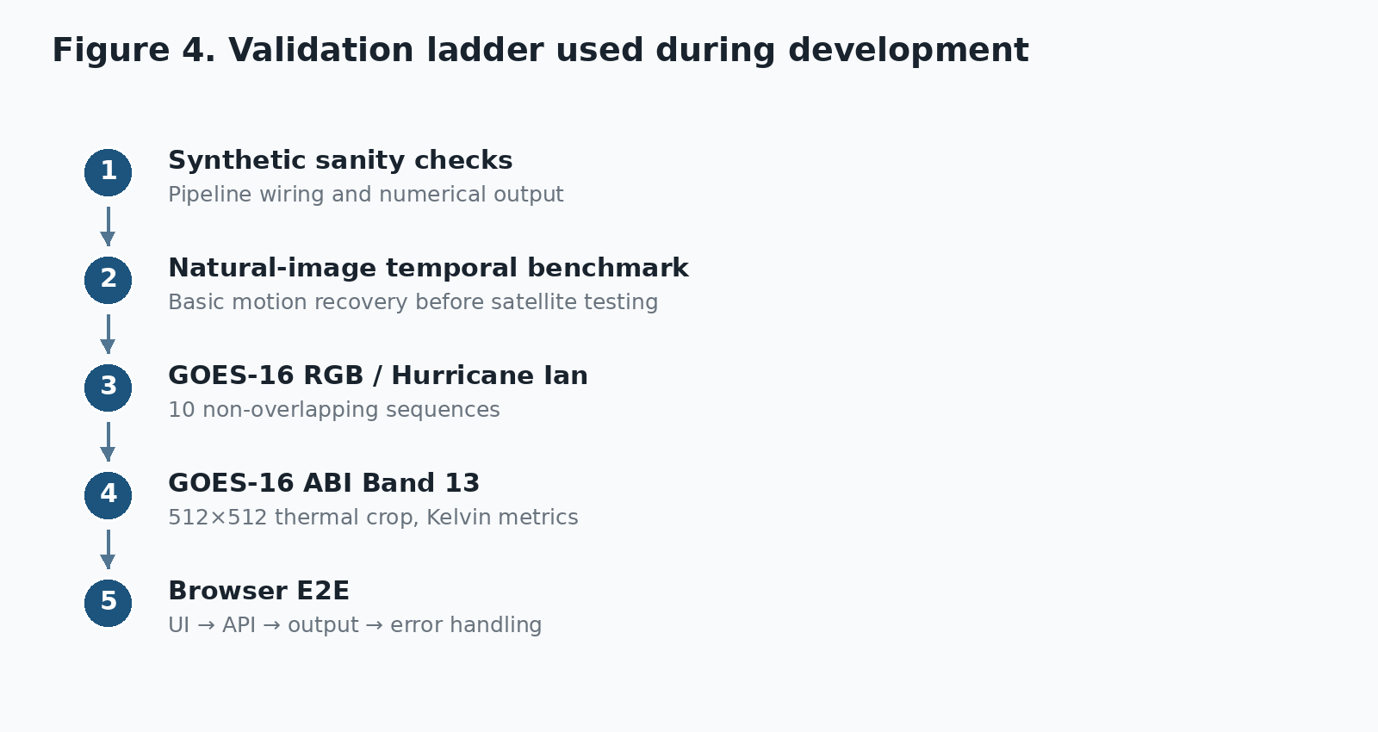
Figure 4. Main validation stages recorded in the project documentation.

10.2 Metrics
Metric | Interpretation
MAE | Mean absolute pixel error. Lower is better.
RMSE | Square-root mean squared error. Lower is better.
PSNR | Signal quality relative to reconstruction error. Higher is better.
SSIM | Structural similarity. Higher is better.
MS-SSIM / FSIM | Additional structural or perceptual checks used in the wider evaluation framework.
BT-RMSE | Brightness-temperature error in Kelvin for the thermal experiment.

10.3 Baselines
The implemented comparison uses linear interpolation as the main reference and, in the reproducible synthetic demo, also includes TV-L1 based warping. The idea is not to claim that every classical method has been exhausted, but to establish a minimum baseline before attributing value to the learned model [5].

10.4 Test Coverage
The current repository includes unit tests, a browser E2E test and a reproducible synthetic pipeline. The project README records 173 tests passed with one skipped in the documented test run, while the separate browser report confirms that the upload, API invocation, result rendering and invalid-input error path were exercised in Chromium [10][13].

11. Experimental Results

11.1 Synthetic End-to-End Demo
The reproducible demo is deliberately small. It creates synthetic moving-cloud data, trains a tiny IFNet briefly on CPU, generates an intermediate frame, compares it with the withheld truth, and then precomputes web artifacts. The project documentation explicitly calls these numbers integration or sanity results rather than production-quality satellite results [5].
Method | PSNR | SSIM | MS-SSIM | FSIM | BT-RMSE K
Trained IFNet | 26.3637 | 0.9286 | 0.9109 | 0.9604 | 6.8158
Linear blend | 26.1937 | 0.8893 | 0.8724 | 0.9540 | 6.9671
TV-L1 | 25.5260 | 0.8886 | 0.8722 | 0.9509 | 7.5023

The synthetic result is useful mainly because it proves that the complete pipeline can produce real numerical output and web artifacts without internet access or a large satellite dataset. It should not be used as evidence that the model has learned real atmospheric dynamics.

11.2 GOES-16 RGB Multi-Sequence Validation
The ten-sequence experiment uses non-overlapping temporal samples from the Hurricane Ian sequence. RIFE was compared with the linear baseline using MAE, PSNR and SSIM. According to the project validation report, RIFE was better on all three measures in every one of the ten samples [6].
Metric | RIFE | Linear | Observed difference
Mean MAE | 8.598 | 17.747 | 51.5% lower error
Median MAE | 8.567 | 17.751 | Lower
Mean PSNR | 24.839 dB | 19.533 dB | +5.306 dB
Median PSNR | 24.847 dB | 19.524 dB | Higher
Mean SSIM | 0.8109 | 0.6809 | +19.0% relative gain
Median SSIM | 0.8128 | 0.6808 | Higher

What this result tells us Within this evaluated Hurricane Ian sequence, the learned model reproduced the middle frame more accurately than a simple temporal average. Because all ten samples come from one event, the result is strong evidence of local feasibility but not proof of cross-event generalization.

11.3 GOES-16 ABI Band 13 Thermal Evaluation
The Band 13 test is the most physically meaningful experiment in the current set because the output is evaluated in Kelvin rather than only in display-oriented RGB space. The model received a single thermal band, used replicated three-channel input for RIFE compatibility, and was evaluated after conversion back into brightness temperature [7].
Metric | RIFE HDv3 | Linear | Difference
MAE | 0.358 K | 1.688 K | 78.8% lower
RMSE | 0.766 K | 4.544 K | 83.1% lower
PSNR | 45.836 dB | 30.373 dB | +15.463 dB
SSIM | 0.9925 | 0.8734 | Higher

The experiment demonstrates that a pretrained RIFE model can be driven by a scalar brightness-temperature field without changing the internal network architecture. At the same time, the test covers a 512 x 512 crop from one Hurricane Ian sequence, so the result should not be generalized to all atmospheric conditions or used as a claim of near-surface temperature accuracy [7][12].

11.4 Inference and Browser Performance
Measurement | Documented value
RIFE server-side execution | 12.19 ms
Browser/API round-trip | ~1600 ms
E2E outcome | Complete; zero uncaught exceptions
Outputs verified | Generated image, confidence map, inference time

The difference between the 12.19 ms model kernel and the approximately 1.6 second browser round-trip is expected because the latter includes request handling, file transfer and browser-side work. It is important to keep the two numbers separate rather than describing the complete application request as a 12 ms operation [10].

12. Discussion

12.1 What Worked Well
The strongest part of the project is that the interpolation experiment was not left at the model-call stage. The work connects model inference to a testable service, a visual interface and a measurable validation loop. That makes it possible to ask not only "can RIFE produce an image?" but also "does the image agree with a real middle frame, how fast was it produced, and where does the model appear less consistent?"
The Band 13 experiment is another important step. Using a physical thermal variable forces the project to handle units, normalization and invalid values more carefully than a simple RGB demo. The sub-Kelvin MAE reported in the tested crop is promising, while the project documentation is appropriately cautious about what that number means.

12.2 Why the Baseline Still Matters
Linear interpolation is easy to implement and difficult to beat when the motion is slow and nearly linear. A learned model therefore has to justify its extra complexity by recovering structure that a simple blend cannot. The reported experiments show this advantage in the tested sequences, particularly in structural similarity and, for Band 13, in physical-unit error.

12.3 Where the Model Is Likely to Struggle
The failure analysis identifies four recurring issues. First, cloud structures can appear, grow and dissipate rather than simply translate, which violates the assumptions behind rigid optical-flow warping. Second, radiometric conditions can drift because of illumination and atmospheric effects. Third, strong shear can lead to crossing or inconsistent flow vectors. Finally, even small registration errors can be amplified by the flow calculation [12].
These limitations suggest that the next improvement should not be another visual polishing pass on the dashboard. The bigger gain is likely to come from satellite-specific training, better alignment, richer evaluation and a confidence mechanism that is calibrated against real interpolation error.

13. Limitations and Risk Areas
Risk / limitation | Practical implication
Limited event diversity | The strongest real-data validation is centered on Hurricane Ian.
Pretrained backbone | The current RIFE model was not fully fine-tuned on a large multi-event satellite corpus in the documented prototype.
Band 13 crop size | The dedicated thermal experiment is based on a 512 x 512 region.
Confidence calibration | The confidence map is a consistency proxy, not a probabilistic uncertainty estimate.
Cross-sensor comparability | RGB and thermal metrics are not directly comparable across domains.
INSAT operational validation | The architecture targets INSAT-3DS/3DR, but the documented results do not establish operational INSAT performance.
Weather event generalization | Results from one storm sequence should not be assumed to represent all seasons, cloud regimes or motion patterns.

13.1 Research Integrity of the Current Claims
A useful feature of the current documentation is that it separates prototype evidence from intended future capability. The project does not describe the interpolated image as a newly observed physical measurement, and it explicitly states that operational forecasting performance has not been established. Maintaining that distinction will be important in the final presentation and report [4][13].

14. Future Work

14.1 Satellite-Specific Fine-Tuning
The first priority is to train or fine-tune IFNet on real high-cadence thermal satellite sequences. The architecture proposes GOES-19 and Himawari-9 as dense training sources, with temporal hold-out used to create true intermediate supervision [2].

14.2 Cross-Event and Cross-Satellite Validation
The current results should be extended beyond a single storm. A stronger evaluation would include multiple weather systems, seasons, geographic regions and, where possible, independent satellite overlap. The architecture also proposes additional cross-validation through polar-orbiting observations and cross-sensor consistency checks [2].

14.3 INSAT-3DS/3DR Domain Adaptation
The intended application is INSAT-3DS/3DR TIR1. Before making that transition operationally useful, the model must be adapted to the sensor characteristics, spatial grid, radiometric conventions and available validation opportunities of INSAT data. The project roadmap treats this as a separate deployment phase rather than assuming that a GOES-trained network will transfer perfectly [2][4].

14.4 Better Uncertainty Estimation
The current confidence map is useful as a warning layer, but it does not answer the question "what is the expected numerical error?" A future version should compare confidence values with actual per-pixel interpolation error on withheld real frames and calibrate the score accordingly.

14.5 Deployment Optimization
The broader architecture proposes precomputing interpolated frames and serving them as web-ready raster and video artifacts, avoiding model execution during normal dashboard playback. For true on-demand interpolation, the architecture also considers ONNX and TensorRT FP16. These optimizations make sense only after the model quality and validation pipeline are stable [2].

15. Conclusion
FrameFlow demonstrates a complete and technically coherent approach to the problem of temporal interpolation in geostationary satellite imagery. The project starts from a clear observation gap, applies an established optical-flow based VFI model, adapts the data path for both display-oriented RGB and physical thermal imagery, and closes the loop with quantitative evaluation and a browser-accessible interface.
The reported GOES-16 experiments provide a useful proof of concept. RIFE outperformed the linear baseline across all ten documented RGB samples, and the dedicated Band 13 experiment produced a substantial reduction in the reported physical-domain reconstruction error for the tested Hurricane Ian crop [6][7]. The software side is also more complete than a standalone model prototype: the API, dashboard and E2E workflow have been exercised, and the project includes structured contracts and reproducible demo artifacts [3][9][10].
At the same time, the project should be presented for what it is: a research prototype with promising results and a clear route toward stronger validation. The next stage is not to make larger claims; it is to make the evidence broader - more events, more sensors, more real training data, and a proper INSAT evaluation. That is the step that would turn FrameFlow from a convincing prototype into a more complete satellite-technology study.

References
[1] ISRO Bharatiya Antariksh Hackathon 2026, Problem Statement 12, "Fill in the Frames Seamlessly - Enhancing Temporal Resolution of Satellite Imagery using AI/ML based on Optical Flow."
[2] FrameFlow Team, "FrameFlow - System Architecture," Architecture v1.0, 20 June 2026.
[3] FrameFlow Team, "FrameFlow - Interface Contracts (AUTHORITATIVE)."
[4] FrameFlow Team, "Model Card - FrameFlow VFI (satellite Thermal-IR frame interpolation)."
[5] FrameFlow Team, "FrameFlow - end-to-end demo results," generated by make demo.
[6] FrameFlow Team, "Phase 14B: Multi-Sequence Satellite Validation (10 non-overlapping temporal samples from the Hurricane Ian sequence)."
[7] FrameFlow Team, "Phase 15A: GOES-16 ABI Band 13 Prototype."
[8] FrameFlow Team, "RIFE Integration" and "Interpolation Confidence Proxy."
[9] FrameFlow Team, "FrameFlow API Documentation."
[10] FrameFlow Team, "FrameFlow E2E Browser Test Report" and "FrameFlow Dashboard."
[11] FrameFlow Team, "Satellite Dataset Documentation."
[12] FrameFlow Team, "Satellite Imagery Failure Analysis on Pretrained RIFE."
[13] FrameFlow Team, "FrameFlow README / Setup Guide / Implementation Status."
[14] Z. Huang, T. Zhang, W. Heng, B. Shi, and S. Zhou, "Real-Time Intermediate Flow Estimation for Video Frame Interpolation," European Conference on Computer Vision (ECCV), 2022.
[15] Vandal and Nemani, "Temporal Interpolation of Geostationary Satellite Imagery with Task-Specific Optical Flow," IEEE Transactions on Neural Networks and Learning Systems, 2021, cited in the FrameFlow architecture as the principal satellite-specific quality reference.

Appendix A - API Summary
Method | Path | Description
GET | /health | Returns server status, CUDA availability and model-loaded status.
GET | /model/info | Returns model name/variant, device, weight availability and timestep support.
POST | /interpolate | Accepts frame0, frame1 and timestep; returns generated image, confidence map and runtime information.
POST | /evaluate | Accepts frame0, ground truth and frame2; returns MAE, PSNR, SSIM and runtime.

Appendix B - Documentation Status Note
The project folder contains phase-wise implementation records written at different stages of development. One earlier status file records satellite validation as pending, while later phase documents report the GOES-16 multi-sequence validation and the Band 13 experiment as completed. This report treats the later, more specific Phase 14B and Phase 15A validation documents as the current experimental status and retains the earlier note as a historical progress record rather than mixing the two states [6][7][13].

Appendix C - Short Mentor-Facing Project Summary
FrameFlow is a machine-learning based temporal interpolation system for geostationary satellite imagery. The prototype integrates RIFE HDv3, satellite preprocessing, a confidence proxy, quantitative evaluation, FastAPI and a React/Vite dashboard. The documented GOES-16 validation shows consistent improvement over linear interpolation, while the Band 13 experiment reports sub-Kelvin MAE on the tested Hurricane Ian crop. The project is ready for academic evaluation as a research prototype, with cross-event validation, satellite-specific fine-tuning and full INSAT deployment remaining as logical next steps.

